RESEARCH IN BIOTECHNOLOGY

Research in Biotechnology
11:126:497 (1-6 credits by arrangement)
Fall semester
11:126:498 (1-6 credits by arrangement)
Spring or summer semester

Meting times by arrangement
Location by arrangement

CONTACT INFORMATION:
Instructor(s): Chosen laboratory director (Paul R. Meers, course coordinator)
Office Location: 272 Foran Hall
Phone: 848-932-6230 Email: paul.meers@rutgers.edu
Office Hours: by appointment

COURSE WEBSITE, RESOURCES AND MATERIALS:
Canvas site for 11:126:497 or 11:126:498

Normally Offered:
Fall Term (as 11:126:497) and Spring Term and Summer (as 11:126:498). Any faculty member at Rutgers University, Robert Wood Johnson Medical School, or the Cancer Institute of New Jersey who does research in biotechnology, biochemistry, molecular biology or genetics may supervise student research projects (see below for links to find relevant laboratories). Students working in internships at outside biotechnology-related companies can also gain credit through the SPIN internship program.

Pre-requisites and other registration restrictions:
Open to biotechnology and life science majors by special permission from the Biotechnology Curriculum Coordinator. Requires approval of the faculty member who will supervise the research project. Once approval is acquired, a special permission number may be obtained from the Biotechnology Undergraduate Program Director located in Foran Hall.

Format:
The student carries out an independent research project under the supervision of the research advisor. A minimum of 3 hrs/wk per credit in the laboratory is expected.

Description:
The student, under the guidance of a faculty member, carries out a research project. Most often, a faculty member may engage the student in some aspect of a research project that the faculty member is pursuing. However, the student may also identify her/his own project in consultation with the research advisor.

Learning Goals
Upon completing the course, the student will have –
- Gained background knowledge of the field of the project and the specific problem(s) to be addressed using the public literature and coursework, and appropriately summarized it..
- Appropriately stated the hypothesis or hypotheses to be tested and explained the experiments devised to test it.
- Gained proficiency in the laboratory techniques and scientific approaches used in biotechnology to address the specific hypothesis (es) at hand.
- Appropriately documented (e.g. notebook) and analyzed data.
- Learned to interpret data and draw appropriate conclusions and define future possible directions of the work.

Assessment Rubric:

Rubrics | Ranking Scale
 | 1  Unsatisfactory | 2  Satisfactory | 3  Good | 4  Outstanding
Learning Goal 1. Knowledge of the field – factual and conceptual
Learning Goal 2. Statement and justification of hypothesis
Learning Goal 3: Laboratory techniques proficiency
Learning Goal 4 Analysis, presentation and interpretation of data.
Learning Goal 5. Drawing appropriate conclusions and identifying implications and interpreted.

Examinations
None

Other requirements:
All students are expected to write a paper describing the research project at the end of the semester in journal article format. Copies are submitted to the research advisor and the Biotechnology Undergraduate Program Director. A Sakai site dropbox for submitted reports is established each semester for student submissions.

Grading
The research advisor is responsible for reporting a suggested grade for the student and to the Curriculum Coordinator/Program Director. The grade reflects overall performance in the laboratory, including the final report, using the assessment rubric provided.

Additional Information:
To find a lab:
Look at two sources:
1) the list of biotech faculty mentors on the biotech curriculum website
tbd (see list below) (for faculty on this campus) and
2) http://lifesci.rutgers.edu/~molbiosci/faculty (for faculty who do research
in "biotech" at Rutgers and UMDNJ and affiliated hospitals.
Then make a short list (~10) of faculty that most interest you. After doing a little more searching on the web about the research conducted in each of these faculty labs, carefully compose a brief email that 1) tells the prospective mentor about yourself (major,year, college, interests, etc.); 2) states why the you are interested in the research of the faculty mentor; and 3) asking for an appointment to meet the faculty member to talk about the research and possibly working in that faculty member's lab in the coming (semester).
To get credit, enroll in Research in Biotechnology 11:126:497 when you have enough time in your schedule to do three credits (minimum of nine hr/wk in the lab for the entire semester). If you have less time, you should volunteer (or get their feet wet by working with a grad student) until they can enroll for three credits. The program coordinator gives special permission numbers for Research in Biotech after the student has a mentor.
In terms of paid internships, you should visit the SPIN Office in Martin Hall. They should also visit the Career Services Office with help to prepare a resume.
If you desire additional information, speak with the Biotechnology Undergraduate Program Director.

FURTHER INFORMATION

The exciting new world of Biotechnology in the 21st century has developed as a result of the convergence of biological, physical and mathematical sciences to solve problems in ways never before imagined. The breathtaking advance of DNA sequencing is one example of the power of this approach. In Biotechnology, students are trained in a broad range of basic sciences as a foundation for many important real-world applications.

A major part of this training is participation in research. All Biotechnology majors participate in at least 3 credit hours of research. Students have a large number of research laboratories across all the Rutgers campuses from which to choose research projects when positions are available (see SEBS list below or link for non-SEBS labs - http://lifesci.rutgers.edu/~molbiosci/faculty)

Students gain a truly complete understanding of what they have learned in their courses when that knowledge is applied in research. Why is it important to know how to calculate molarities? Why is the relative solubility of hydrophilic and hydrophobic molecules important? Why do I need to know about pKa? Why is it important to know how to keep samples sterile? You will learn in research. You may make exciting new discoveries, but more importantly you will learn to plan an efficient day of research and how to accurately document and interpret your results. Understanding “how research works” is a very important skill whether you become an academic principal investigator or a business development executive of a biotechnology company. Planning and assessing feasibility comes from your direct experience in doing research.

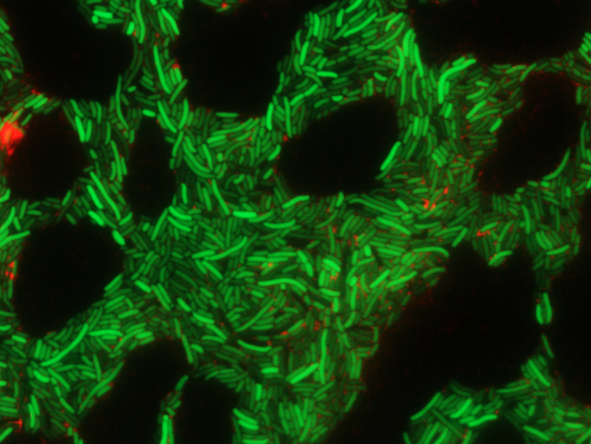

Aside from the Research in Biotechnology course (see below), students can also perform research projects in the SEBS Honors program and George H. Cook Scholars program (links below) at the School of Environmental and Biological Sciences. (http://sebshonors.rutgers.edu/general_honors_program/)
(http://sebshonors.rutgers.edu/gh_cook_scholars_program/)
In addition, students can do Biotechnology research in the university-wide Aresty program (https://aresty.rutgers.edu/). An internship or paid work in Biotechnology at a company outside Rutgers can also qualify for research credit through the Rutgers SPIN program (http://sebsspin.rutgers.edu/).

Biotechnology students have distinguished themselves in each of these programs. For instance, in the most recent Aresty Undergraduate Research Symposium, Biotechnology students received a Best Poster Award (Daniel Hollerbach) and two Honorable Mentions (Katie Fullerton and Connor Lamontagne). Some students have even presented research at national meetings of large professional scientific societies (e.g. Biophysical Society).
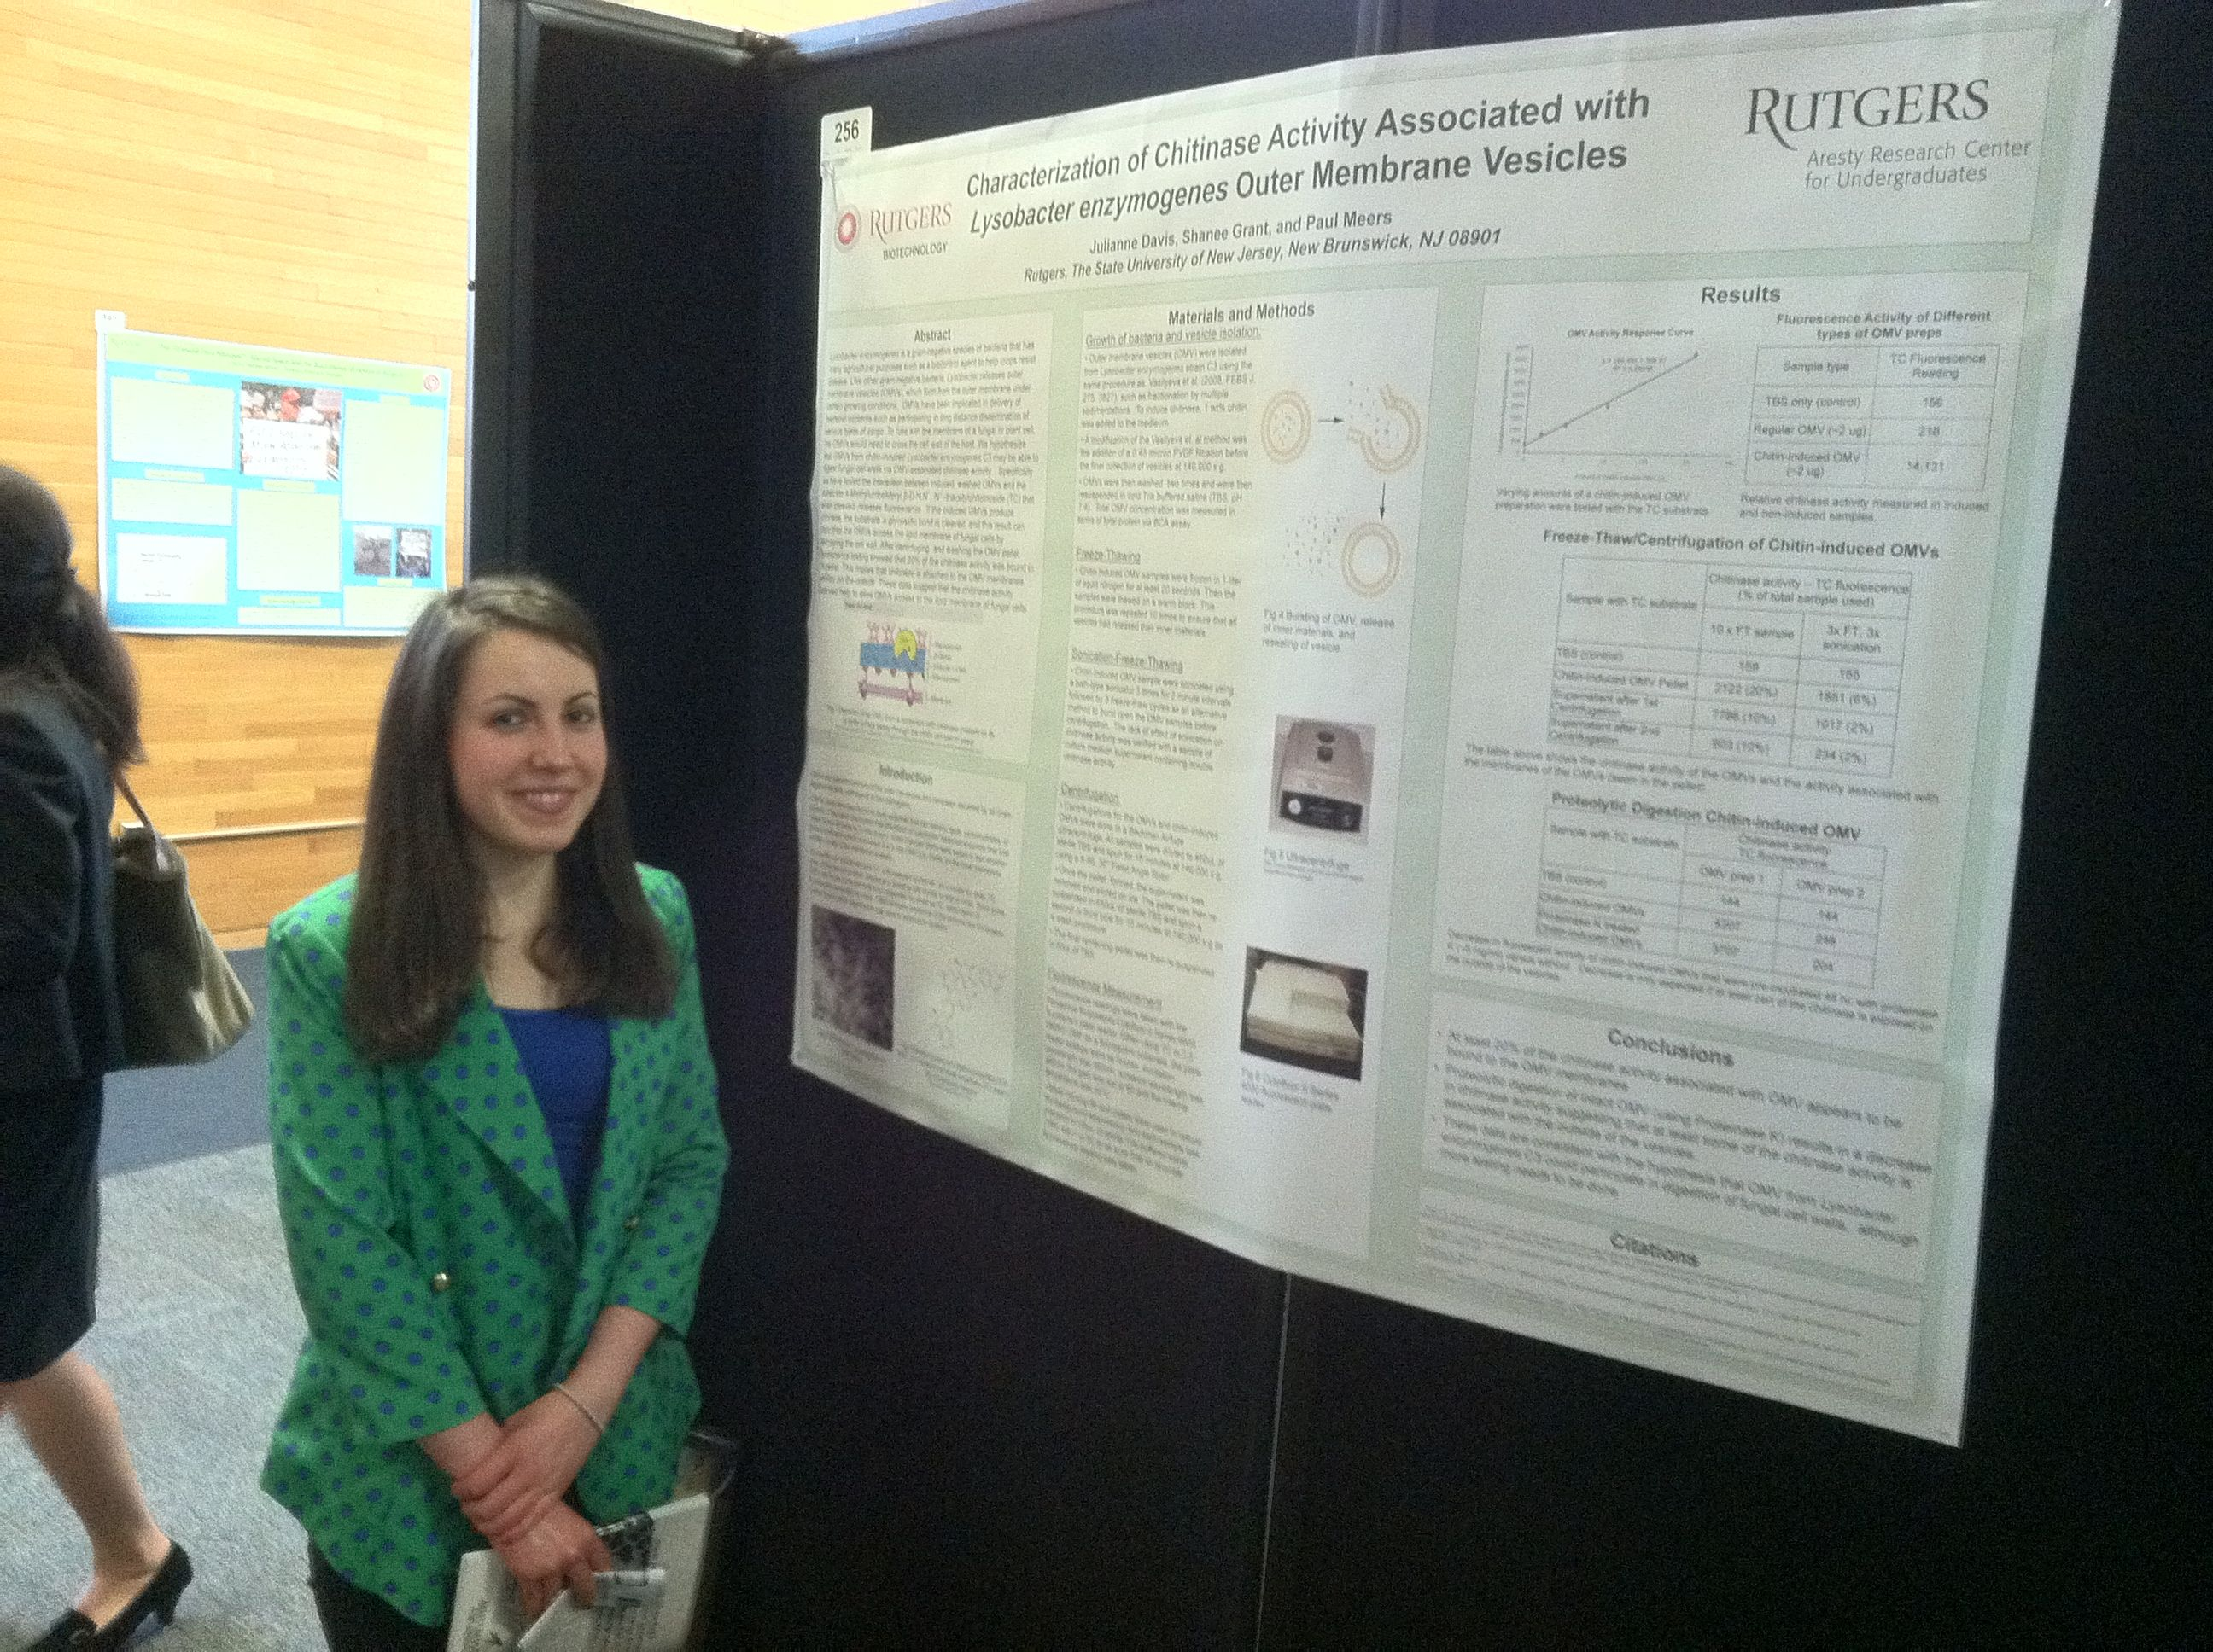

POLICIES AND RESOURCES:
ACCOMODATIONS for Students with disabilities
Please follow the procedures outlined at https://ods.rutgers.edu/students/registration-form. Full policies and procedures are at https://ods.rutgers.edu/

ABSENCE POLICY
Students are expected to attend all classes; if you expect to miss one or two classes, please use the University absence reporting website https://sims.rutgers.edu/ssra/ to indicate the date and reason for your absence. An email is automatically sent to me.

ACADEMIC INTEGRITY
The university's policy on Academic Integrity is available at http://academicintegrity.rutgers.edu/academic-integrity-policy. The principles of academic integrity require that a student:
- properly acknowledge and cite all use of the ideas, results, or words of others.
- properly acknowledge all contributors to a given piece of work.
- make sure that all work submitted as his or her own in a course or other academic activity is produced without the aid of impermissible materials or impermissible collaboration.
- obtain all data or results by ethical means and report them accurately without suppressing any results inconsistent with his or her interpretation or conclusions.
- treat all other students in an ethical manner, respecting their integrity and right to pursue their educational goals without interference. This requires that a student neither facilitate academic dishonesty by others nor obstruct their academic progress.
- uphold the canons of the ethical or professional code of the profession for which he or she is preparing.
Adherence to these principles is necessary in order to ensure that
- everyone is given proper credit for his or her ideas, words, results, and other scholarly accomplishments.
- all student work is fairly evaluated and no student has an inappropriate advantage over others.
- the academic and ethical development of all students is fostered.
- the reputation of the University for integrity in its teaching, research, and scholarship is maintained and enhanced.
Failure to uphold these principles of academic integrity threatens both the reputation of the University and the value of the degrees awarded to its students. Every member of the University community therefore bears a responsibility for ensuring that the highest standards of academic integrity are upheld.

STUDENT WELLNESS SERVICES

Just In Case Web App http://codu.co/cee05e
Access helpful mental health information and resources for yourself or a friend in a mental health crisis on your smartphone or tablet and easily contact CAPS or RUPD.

Counseling, ADAP & Psychiatric Services (CAPS)
(848) 932-7884 / 17 Senior Street, New Brunswick, NJ 08901/ www.rhscaps.rutgers.edu/
CAPS is a University mental health support service that includes counseling, alcohol and other drug assistance, and psychiatric services staffed by a team of professional within Rutgers Health services to support students’ efforts to succeed at Rutgers University. CAPS offers a variety of services that include: individual therapy, group therapy and workshops, crisis intervention, referral to specialists in the community and consultation and collaboration with campus partners.

Violence Prevention & Victim Assistance (VPVA)
(848) 932-1181 / 3 Bartlett Street, New Brunswick, NJ 08901 / www.vpva.rutgers.edu/
The Office for Violence Prevention and Victim Assistance provides confidential crisis intervention, counseling and advocacy for victims of sexual and relationship violence and stalking to students, staff and faculty. To reach staff during office hours when the university is open or to reach an advocate after hours, call 848-932-1181.

Disability Services
(848) 445-6800 / Lucy Stone Hall, Suite A145, Livingston Campus, 54 Joyce Kilmer Avenue, Piscataway, NJ 08854 / https://ods.rutgers.edu/
Rutgers University welcomes students with disabilities into all of the University's educational programs. In order to receive consideration for reasonable accommodations, a student with a disability must contact the appropriate disability services office at the campus where you are officially enrolled, participate in an intake interview, and provide documentation: https://ods.rutgers.edu/students/documentation-guidelines. If the documentation supports your request for reasonable accommodations, your campus’s disability services office will provide you with a Letter of Accommodations. Please share this letter with your instructors and discuss the accommodations with them as early in your courses as possible. To begin this process, please complete the Registration form on the ODS web site at: https://ods.rutgers.edu/students/registration-form.

Scarlet Listeners
(732) 247-5555 / http://www.scarletlisteners.com/
Free and confidential peer counseling and referral hotline, providing a comforting and supportive safe space.

